Detailed list of second-half topics to focus on:

* Fixed income Calculating bond prices and YTM o Calculating duration and convexity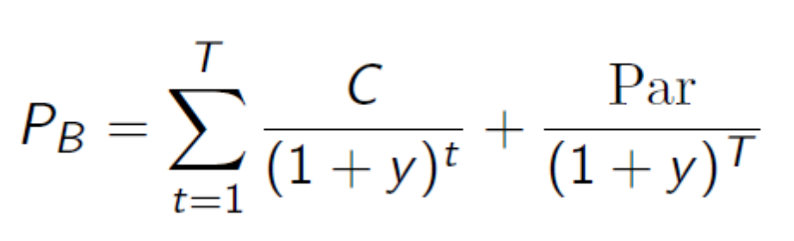
* 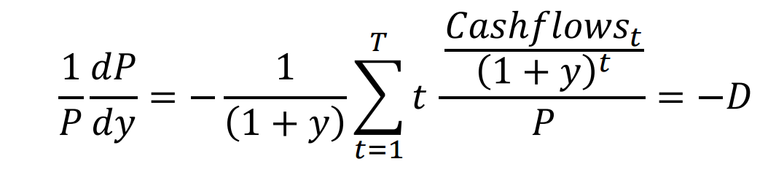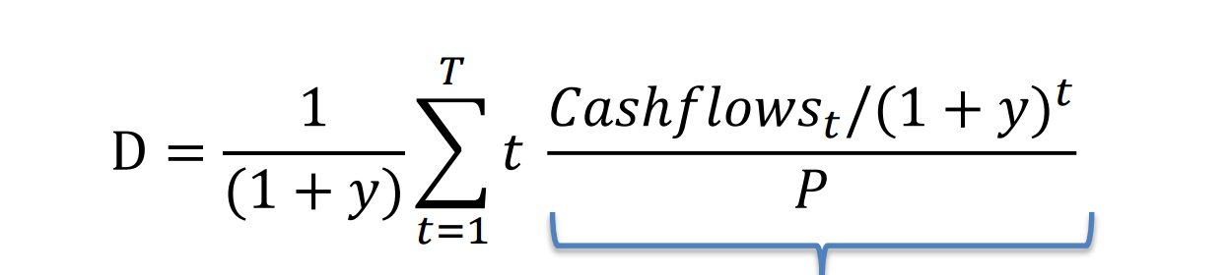
* The linear and quadratic approximations o Term structure and the expectations hypothesis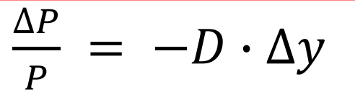
* Financial markets and High-Frequency Trading o Limit order book trading, bid-ask spreads, price impact, market making

Limit order book does not immediately excute the trade. bid-ask spreads. The difference bewteen bit and ask

price impact, The buyer and seller effect the price by their own acts

Market making: move against them

Characteristics of high-frequency traders; are HFTs beneficial for market quality? Yes, imporve the liquity of assets.

1 market making

2 cross-market arbitrage

3 trading on signals

• Interest rates and monetary policy o The Fisher equation

i = r + π

Know about: potential output, cyclical vs. structural unemployment, sticky wages, the NAIRU, inflation, the Philips curve, the natural interest rate, liquidity traps

Suppose initially that every worker is employed

Cyclical Unemployment is short-term unemployment due to recessions

Structural Unemployment is long-term unemployment

sticky price means if the wage can fall restore to the full-employment stage.

NAIRU:Non-Accelerating-Inflation-Rate of Unemployment.Thought to be currently ~4-5% for the U.S

Both wages and prices increase simultaneously

Philips curve: the tradeoff between unemployment rate and the inflation rate.

The liquidity trap: continuous recession. because of the negative interest rate.

IS-LM model: both the intuition and the type of question from the problem set

The IS (investment-savings) curve y = C + I(r) + G + NX

LM curve LM (liquidity-money) curve L(r,y) = M

▪ Policy experiments: what happens if C or G increases, etc.? How does this shift the curve?

Bank balance sheets: leverage, liquidity, ROE, net interest margins ▪ The structure of the banking system and the Fed

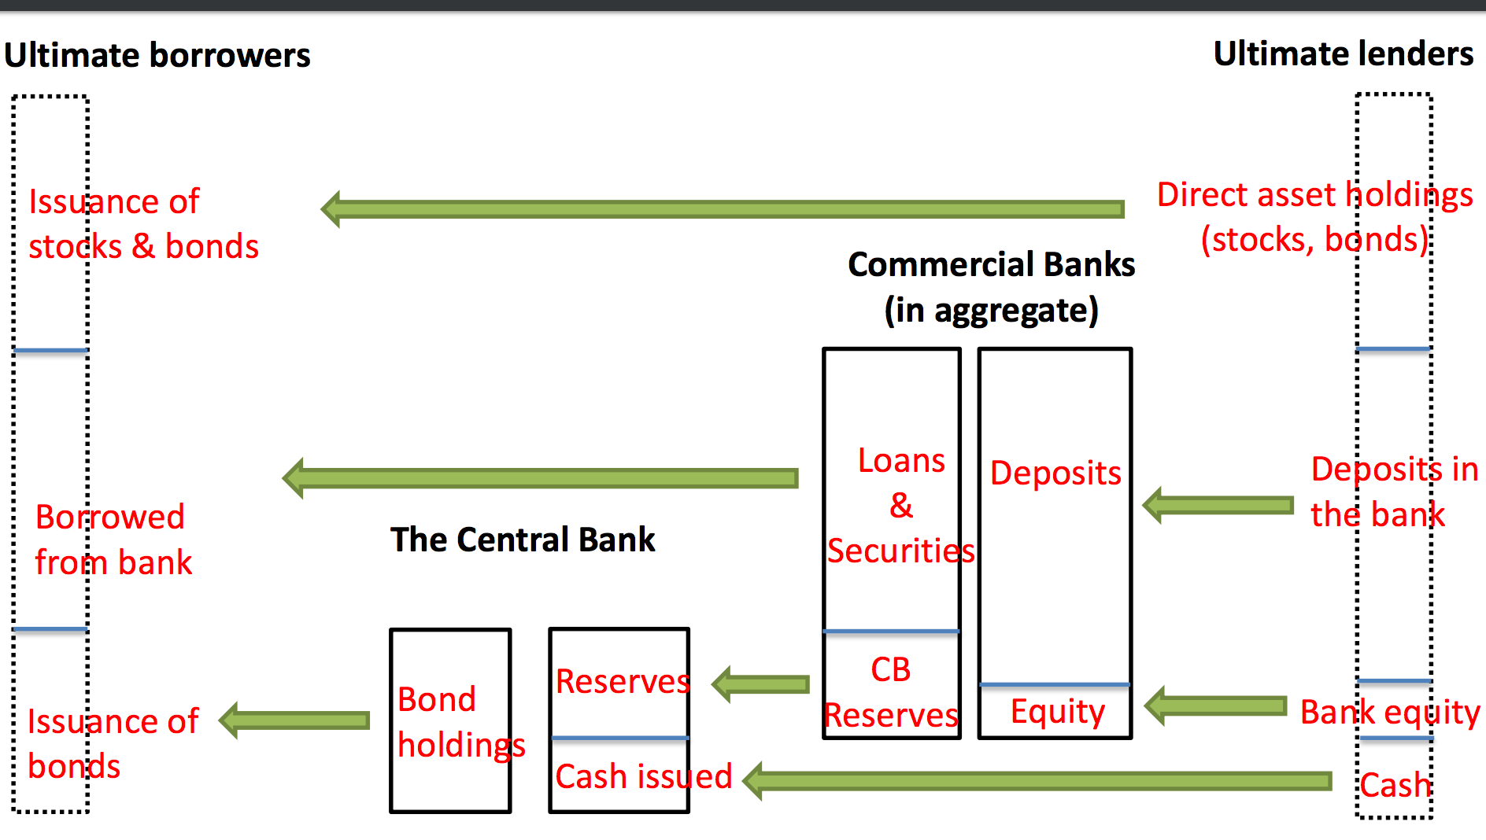

Banks as intermediaries between savers and borrowers • Cash is a central bank liability Banks deposit money in the Fed . Broad money (M2) versus narrow money (M0) narrow money: M0 is central bank liabilities. Broad Money M2 is all commercial bank deposit and savings accounts. Currencies o Real exchange rates vs. nominal exchange rates . How they’re determined in the long-run

Appreciation vs. depreciation, how this affects imports and exports The pros and cons of floating exchange rates

Sticky real wages and adjustment problems / capital imbalances

Reasons countries have chosen fixed-exchange rate regimes (fiscal and

monetary discipline) ▪ Problems with overvalued currencies and sudden devaluations

Carry trades and covered/uncovered interest rate parity o Capital flows and the current accounts o Foreign exchange interventions o The causes and consequences of currency crises:

• Financial crises and regulation Causes and consequences of financial crises 1 Bank lending boom 2 Real estimate boom 3 capital inflows. consequences: 1 contraction in bank lending 2 Deep persistent recessions 3 Decrease in asset prices 4 increase in government debt: because decreased tax revenue 5 political sequence

Bank runs: the intuition of the Diamond-Dybvig model o The “shadow” banking system 1 Bank provide screening and monitoring function 2 bank provides liquidity insurance for depositor Shadow bank system: these banks are not regulated like banks Do not have deposit insurance

Run on repo. The 2007-8 global financial crisis o Regulations studied in class

capitical requirement: bank needs  higher capital repquirement since the credit boom. banks need related capital requirement during financial distress.

▪Basel III and capital requirements

▪ Central clearing for Credit Default Swaps ▪ Money market mutual fund reforms

clearinghouses:

A well-captialized learninghouse prevents counterparty defaults

monitor the capital of one party

oRisk premia in the aftermath of financial crises

▪ Intuition behind the intermediary asset pricing view